# Overview

Delegation of administrative control is done to distribute the load of managing an Active Directory domain. This is normally done to allow administrators in remote locations to administer the users and workstations at their location. It can also be used to give a group permission to manage a specific type of object like users or computers. In this Guided Practice, you will explore Active Directory permissions and use the delegation of administrative control wizard to assign permissions to groups.

# Objectives

* Be able to view and explain the security descriptor for and AD object.
* Be able to configure security for AD objects.

# Prerequisites

Guided Practice – Creating Active Directory Objects

# Scenario

ABS Corporation is looking into increasing its security. They would like to implement a least privilege and separation of duties policy by delegating administration of Active Directory objects using groups so that users can be easily configured to manage different locations or departments.

# Tasks

## Viewing AD object SEcurity descriptors

Determine which user accounts have permission to view or modify Active Directory objects by viewing the security attributes for these objects. In this step, you will use **Active Directory Users and Computers** to view the permissions on an Active Directory object.

To view the security descriptor for the domain object in AD, perform the following:

1. Login to the **CIS256-DC1** virtual machine
2. Open **Active Directory Users and Computers**
3. Configure **Active Directory Users and Computers** so that you can **view** the **Advanced Features.**
4. Open the **Properties** for the **abscorp.com** domain object.
   1. Select the **Security** tab to **view** its **discretionary access control list.**
   2. Use the **DACL** to **fill** **in** the **table** below.

|  |  |
| --- | --- |
| Group | Permissions |
| Everyone |  |
| Authenticated Users |  |
| System |  |
| Domain Admins |  |
| Enterprise Admins |  |
| Administrators |  |

1. When you are done, close the dialog box.

## Using the Delegation of Administrative Control wizard

The Delegation of Administrative Control Wizard is the easiest way to assign granular permissions to objects in the domain or OU.

### Granting Full Control Permissions to the objects in an OU

ABS Corporation would like to give the **GV-Admin** group permissions to manage all the objects in the Greenville location.

To delegate administrative control of Greenville to the GV-Admin group, perform the following:

1. 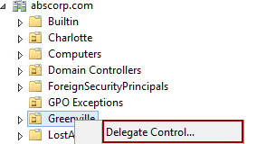In **Active Directory Users and Computers**, create a new globalgroup named **GV-Admin** in the **Users** container.
2. Browse to the **Greenville** OU and select **Delegate Control…** from the context menu to launch the **Delegation of Control Wizard** as shown in the figure.
3. 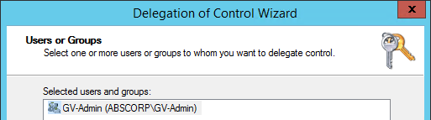On the **Welcome to the Delegation of Control Wizard** page of the wizard, **Active Directory** the page and then **Click** the **Next** button.
4. On the **Users or Groups** page of the wizard, **Click** the **Add…** button and **add** the **GV-Admin** group and then **Click** the **Next** button.
5. On the **Tasks to Delegate** page of the wizard, select the following tasks and then **click** the **Next** button:
   1. 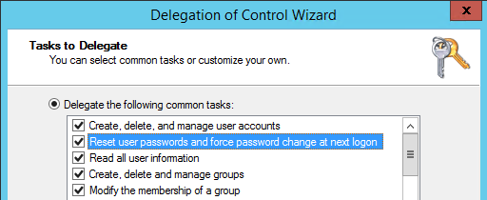**Create, delete, and manage user accounts**.
   2. **Reset user passwords and force password change at next logon.**
   3. **Read all user information.**
   4. **Create, delete, and manage groups.**
   5. **Modify the membership of a group.**
6. On the **Completing the Delegation of Control Wizard** page of the wizard, review the results and then **Click** the **Finish** button.
7. Verify the settings by viewing the security tab in the properties for the **Greenville** OU object and verifying the permissions.
8. Repeat the procedure above to give **CH-Admin** group control of the **Charlotte** OU and **PI-Admin** group control of the **Pickens** OU.
9. Add **Anne Young** to the **CH-Admin** group and the **PI-Admin** group.
10. Add **David Hicks** to the **GV-Admin** group.

### Granting Password Reset Permissions for Objects

Your organization would like to delegate the task of resetting passwords in the Greenville location to a group called **GV-PassAdmin**. To do this, perform the following:

1. Create a group in the **Greenville** OU called **GV-PassAdmin.**
2. Open **Active Directory Users and Computers**
3. Select **Delegate Control…** from the context menu for the **Greenville OU.**
4. Complete the wizard using the information below
   1. Users or Groups: **GV-PassAdmin.**
   2. Tasks to Delegate: **Reset user passwords and force password change at next logon.**
5. Addthe user **Cody Decker** (**codecker**) in the Greenville IT department to the **GV-PassAdmin**.
6. Verify the user can **reset** **passwords** for users in the **Greenville OU**.
   1. Add the **GV-PassAdmin**, **GV-Admin**, **CH-Admin**, and **PI-Admin** groups to the **Remote Desktop Users** Built-in local group in the **abscorp.com** domain. This will allow the administrative users to access the Domain Controllers in the domain.
   2. Verify that the user accounts in the **Greenville OU** are enabled.
   3. Log in as **Cody Decker** and verify that you can reset a password for a use account in the **Greenville OU**.

**Note**: You can log into **CIS251-Client1** or **CIS256-Client2** and then access **CIS256-DC1** via **Remote Desktop** or you can access **CIS256-DC1** through an enhanced Hyper-V session.

* 1. Reset a password for a user in Greenville **OU**.

## Submission Requirements

1. **Download** the **grading** **script** from the assignment page to the **C:\Scripts** folder.
2. Check your lab by running the following command:

Invoke-Pester -Path C:\Scripts\GP12-Delegating_Administrative_ Control.test.ps1

**Note**: You will see a security warning when running the script. Enter **R** to run the script.

If you want to see more detail, add **-Output Detailed** to the command. This may assist you with troubleshooting

Invoke-Pester -Path C:\Scripts\GP12-Delegating_Administrative_ Control.test.ps1 -Output Detailed

1. You should not see any red in the output. Red in the PowerShell way of telling you that an error condition exists. Most of the time, the output will tell you what is wrong. If it is not obvious, contact your teacher and ask for assistance. You will be learning PowerShell during this term. **Correct** any **errors** you may have and run the script until all the output has no red. You should see the output like the images below.

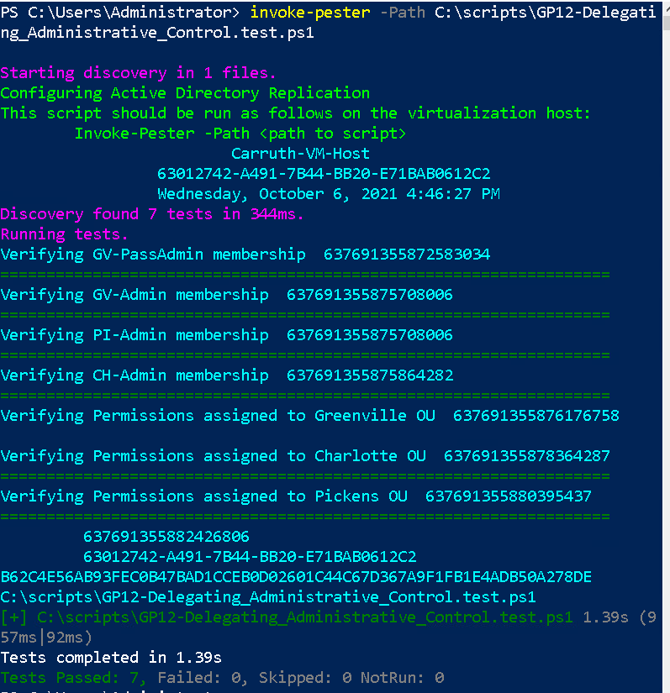

1. Capture a snippet that shows the PowerShell Command and all its output. If you must use more than one snippet to capture the output, you must have at least **one line of overlap** in the snippets. The text in the snippets **must be legible** when pasted into the Word document. Paste the snippet(s) into a **new** **Word** **document.**
2. **Upload** the **document** in the submission area for the assignment.